1. *What scope of emissions should we recommend be included in Bank ABC's target-setting?*

According to the peer bank research, it seems to be the industry standard to include Scope 3 emissions, although these are often the largest, hardest to measure and have typically varied methods of measurement.

1. *Within the Oil & Gas industry, what sub-sectors should be included?*

upstream, downstream and integrated sub-sectors for Oil-Gas industry

1. *What metrics should be used to measure the emissions?*

PEI/ Absolute financed emissions

**Peer research:**

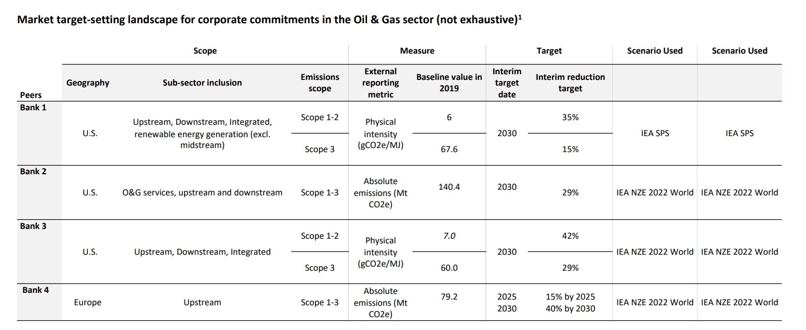

**Target metrics:**

Absolute financed emissions:

The emissions attributed to a bank based on its financing activities to clients. Driven by client emissions and the financing.

$$∑\frac{\text{ Financing to client }}{\text{ Company EVIC}\text{1} }×\text{ Company emissions}$$

* Calculate for each company and then sum up
* Expressed as MtCO2e

Physical emissions intensity (PEI)

The physical emissions intensity (emissions / production) attributed to a bank based on the financing-weighted intensities of its clients. Driven by client-level intensities, weighted by % of financing to client.

$$∑\frac{\text{ Company emissions }}{\text{ Company production }}×\frac{\text{ Financing to client }}{\text{ Total sector financing }}$$

* Calculate for each company and then sum up
* Expressed as kgCO2e / “production” metric

Financed emissions lending intensity (FELI):

The financed emissions lending intensity (emissions / enterprise value) attributed to a bank based on the financing-weighted intensities of its clients. Driven by client-level intensities, weighted by % of financing to client

$$∑\frac{\text{ Company emissions }}{\text{ Company }{\text{ EVIC }}^{1}}×\frac{\text{ Financing to client }}{\text{ Total sector financing }}$$

* Calculate for each company and then sum up
* Expressed as gCO2e / $ lent

EVIC:

the Enterprise Value Including Cash (EVIC) of each client. EVIC is a measure of a company's total value that includes its equity value and the cash it holds and is calculated by adding the company's market capitalization (equity value) to its cash and cash equivalents.